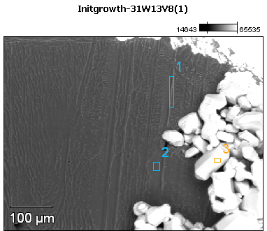

Image Name: Initgrowth-31W13V8(1)

Image Resolution: 512 by 384

Image Pixel Size: 1.24 µm

Acc. Voltage: 13.0 kV

Magnification: 200

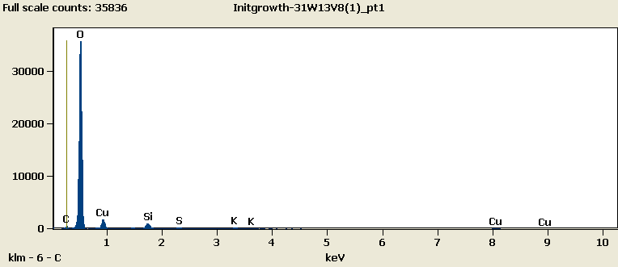

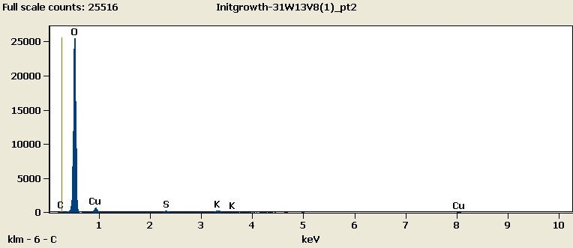

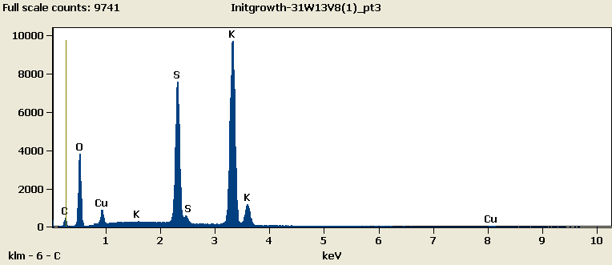

Weight %

|  |  |  |  |  |  |  |
| --- | --- | --- | --- | --- | --- | --- |
|  | ***C-K*** | ***O-K*** | ***Si-K*** | ***S-K*** | ***K-K*** | ***Cu-L*** |
| ***Initgrowth-31W13V8(1)_pt1*** | 2.70 | 76.20 | 2.05 | 0.55 | 1.09 | 17.41 |
| ***Initgrowth-31W13V8(1)_pt2*** | 0.56 | 85.17 |  | 1.01 | 2.47 | 10.79 |
| ***Initgrowth-31W13V8(1)_pt3*** | 4.19 | 25.08 |  | 20.93 | 45.10 | 4.71 |

Weight % Error (+/- 1 Sigma)

|  |  |  |  |  |  |  |
| --- | --- | --- | --- | --- | --- | --- |
|  | ***C-K*** | ***O-K*** | ***Si-K*** | ***S-K*** | ***K-K*** | ***Cu-L*** |
| ***Initgrowth-31W13V8(1)_pt1*** | ±0.09 | ±0.25 | ±0.05 | ±0.05 | ±0.07 | ±0.19 |
| ***Initgrowth-31W13V8(1)_pt2*** | ±0.09 | ±0.29 |  | ±0.08 | ±0.12 | ±0.22 |
| ***Initgrowth-31W13V8(1)_pt3*** | ±0.16 | ±0.21 |  | ±0.12 | ±0.23 | ±0.12 |

# Cations

|  |  |  |  |  |  |  |
| --- | --- | --- | --- | --- | --- | --- |
|  | ***C-K*** | ***O-K*** | ***Si-K*** | ***S-K*** | ***K-K*** | ***Cu-L*** |
| ***Initgrowth-31W13V8(1)_pt1*** | 0.00 | 0.00 | 0.00 | 0.00 | 0.00 | 0.00 |
| ***Initgrowth-31W13V8(1)_pt2*** | 0.00 | 0.00 |  | 0.00 | 0.00 | 0.00 |
| ***Initgrowth-31W13V8(1)_pt3*** | 0.00 | 0.00 |  | 0.00 | 0.00 | 0.00 |